**48.4. Spring Security - Adding Login Error Message**

**Logging Error Message**:

In our logging form if user insert wrong username or password then we display an error message. But in this state our page doesn’t show any error message.

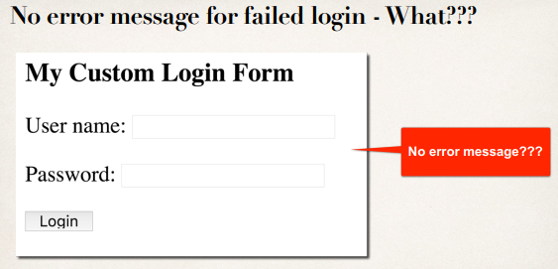

Spring Security's default login page have built-in support for error message. For our custom login page, we need logic to handle for login error message.

**Failed Login**:

* When login fails, by default Spring Security will …
* Send user back to your login page
* Append an error parameter called: **?error**

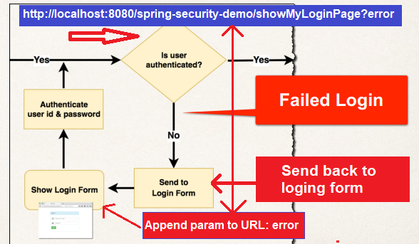

In the above diagram we will see how the **"error"** param map with the URL. We can check the parameter and then write code accordingly.

**Development process**:

1. Modify custom login form
   * Check the **error** parameter **(JSTL can help with this)**
   * If **error** parameter exists, show an error message **(JSTL can help with this)**

**Modify form – check for error**:

Use JSTL

<%@ taglib prefix=*"c"* uri=*"http://java.sun.com/jsp/jstl/core"*%>

<form:form

action=*"*${pageContext.request.contextPath}*/authenticateTheUser"*

method=*"POST"*>

<!-- Check for login error -->

<c:if test=*"*${param.error != null }*"*>

<i class=*"failed"*>Sorry!!! You entered invalid username/password</i>

</c:if>

<p>

User Name: <input type=*"text"* name=*"username"* />

</p>

<p>

Password: <input type=*"password"* name=*"password"* />

</p>

<input type=*"submit"* value=*"Login"* />

</form:form>

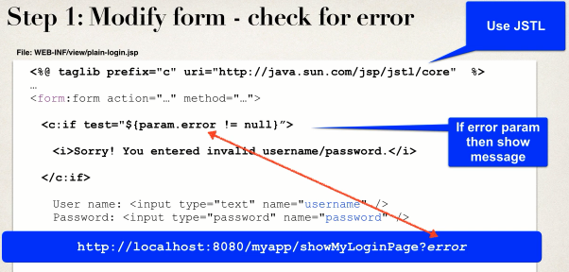

48.4. Spring Security - Adding Login Error Message